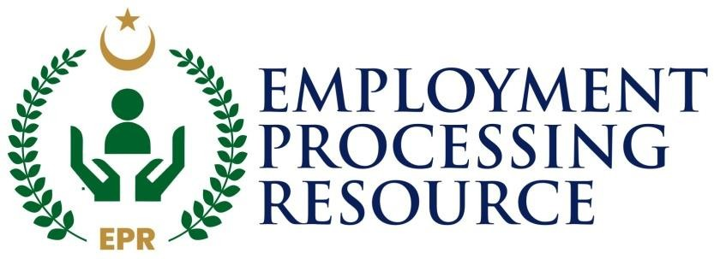

EPR SCREENING TEST / INTERVIEW DETAILS

BALOCHISTAN

*Registration Officer / Assistant Registration Officer / Invigilation Staff*

*IMPORTANT:*

1. If number of candidate’s less than specific quantity, EPR reserved rights to accommodate candidate in near center.
2. Also direct interview can be scheduled instead of written screening test.
3. ***Screening Test Pattern ( Written )***

Type: **MCQ’s** No. of MCQ’s: **100** Test Time: **60 Minutes**

1. ***Test Pattern***

|  |  |  |
| --- | --- | --- |
| ***Sr. #*** | ***Subject*** | ***Question Percentage*** |
| 01 | English ( Basic Grammar) | **20 %** |
| 02 | Pakistan Affairs (1947- 2025) | **15 %** |
| 03 | Everyday Science | **20 %** |
| 04 | EPR Department Knowledge **( All from EPR Website** [**www.epr.org.pk)**](http://www.epr.org.pk/) | **30 %** |
| 05 | Province Affairs ( Candidate Relevant Province) | **15 %** |

NOTE:

1. **Candidates can download their Roll Number details from EPR website Career section on given date.**
2. **Bring the Original CNIC and Print of Roll Number details in Test Center.**
3. **Mobiles Phones & Other electronic gadgets are NOT ALLOWED in test center.**
4. **Please don’t bring mobiles at test center. Otherwise welcome counter will charge Rs. 50/- to secure your mobile outside the examination hall.**

**Project Manager** Dated **21-04-2025**

**>> Uploaded in EPR Career Update section for candidate’s information.**